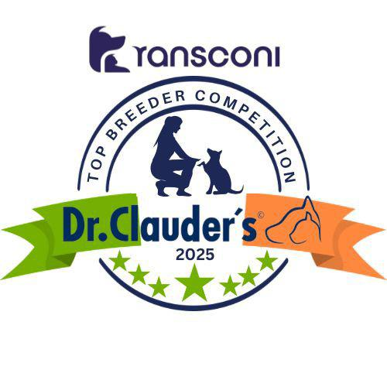

GERMAN SHEPHERD DOG
Albert Balmer (Alberdale) 47

GERMAN SHEPHERD L/C
Albert Balmer (Alberdale) 29

KOMONDOR
Toni Saunders (Regerastace) 16

LANCASHIRE HEELER
Julia Swann (Swanndale) 10

MINIATURE AMERICAN SHEPHERDS
Theodora Gladishevska (Totally Addicted) 9

MUDI
Toni Saunders (Regerastace) 81

OLD ENGLISH SHEEPDOG
Geraldine Mulrooney (Bellablue) 33

PUMI
Monika Vanourek (Putira) 31

PYRENEAN SHEEPDOG
Mr & Mrs Flint (Sandytrail) 8

SCHIPPERKE
Mr, Mrs & Miss Donaldson (Zorbaloo) 7

SHETLAND SHEEPDOG
Grainne Keeling (Kishdigra) 47

SLOVAKIAN CHUVACH
Olga Buresova (Z Hanacke Strane) 8

TATRA SHEPHERD DOG
Alicja Ryan 9

WELSH CORGI CARDIGAN
Miss Fychan (Glynaeron) 7

WELSH CORGI PEMBROKE
Alan Matthews (Craigycor) 57

WHITE SWISS SHEPHERD
Erik Lajbner (Niktel) 21
Agnieszka Jadczak 21
AUSTRALIAN CATTLE DOG
Paulo Colleta (Banana Bender) 5

AUSTRALIAN KELPIE
Mathilde Boissiere (Des Fondues De Chocolat) 11

AUSTRALIAN SHEPHERD DOG
Karen McDevitt (Caronlea) 52

BELGIAN SHEPHERD GROENENDAEL
Paul, Jean & Kelly Lawless (Revloch) 63

BELGIAN SHEPHERD LAEKENOIS
Jan Ralph (Bonvivant) 19

BELGIAN SHEPHERD MALINOIS
Stijn Van Hamme (V.D Vaardekenshoeve) 23

BELGIAN SHEPHERD TERVUEREN
A.McLaren & J-L.Vandenbemden (Corsini) 14

BERGAMASCO
Mr & Mrs Sandford (Boscoantico) 6

BOUVIER DES FLANDRES
Clare Burnett (Mon Cher) 56

BRIARDS
Pavla Firlova (Moravia Campanella) 12

CATALAN SHEEPDOGS
F Olle Segura (Holybeck) 10

COLLIE BEARDED
Cornelia Loest & Paul Roeland (Firstprizebears) 36

COLLIE BORDER
Mr & Mrs Connolly (Huntly) 53

COLLIE ROUGH
Averil Kelly (Evalane) 34

COLLIE SMOOTH
Jana Semianova (Mightys Spring Meadow) 19

CZECH WOLFDOGS
Ms R.Bailey (Akna) 19

GROUP 1
Group 1 Leaders
Regerastace Mudi (81)

D

Congratulations to the Leaders
in the DR CLAUDERS
Top Breeder Competition 2025
The competition identifies the most consistent Breeders of top winning dogs at All Breed Championship Shows within each breed and ran from
1st January to 31st December, 2025
(Results up to and Including All-Irl Bull Breeds)

Breeders gain points from Green Star wins at
ALL BREED CHAMPIONSHIP SHOWS as follows:
5 POINTS awarded for the first Green Star won by a dog of their breeding
1 POINT awarded for subsequent Green Stars won by that same dog.

Each Breed Winner will receive a Diploma, Rosette and Product
Each Group Winner will receive a Diploma, Rosette, Crystal and Product
There will also be a prize for the Overall Winner

