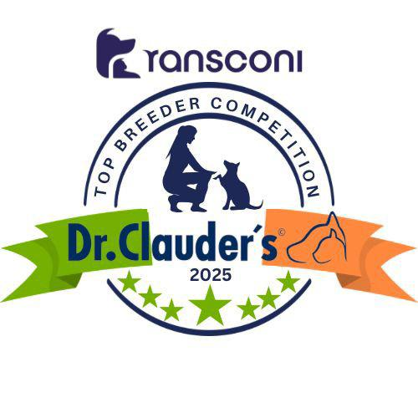

AFGHAN HOUND
Domenico Traversari (Altside) 21

AZAWAKH
Kieran Young (Stonemartin) 27

BORZOI
Karen Arden (Monterun) 17

DEERHOUND
Mr Charles (Rathcreevagh) 24

GREYHOUND
Viara Gentchev (Greyfort) 64

HUNGARIAN GREYHOUND
Agnieszka Nieznanska (Aislingalainn) 9

IRISH WOLFHOUND
Tim, Ian & Marion Finney (Gulliagh) 36

ITALIAN GREYHOUND
Margaret Corr (Crystalclear) 43

SALUKI
Breda Dunne (Saffurah) 17

SLOUGHI
V.A Schachinger (De Polvo Magico) 8

WHIPPET
Messrs Demmerling, Bartusch & Khan (Gentle Mind) 51
Group Leaders
Greyfort Greyhounds (64)

GROUP 10
Congratulations to the Leaders
in the DR CLAUDERS
Top Breeder Competition 2025
The competition identifies the most consistent Breeders of top winning dogs at All Breed Championship Shows within each breed and ran from
1st January to 31st December, 2025
Results up to and including All-Irl Bull Breeds.

Breeders gain points from Green Star wins at
ALL BREED CHAMPIONSHIP SHOWS as follows:
5 POINTS awarded for the first Green Star won by a dog of their breeding
1 POINT awarded for subsequent Green Stars won by that same dog.

Each Breed Winner will receive a Diploma, Rosette and Product
Each Group Winner will receive a Diploma, Rosette, Crystal and Product
There will also be a prize for the Overall Winner

