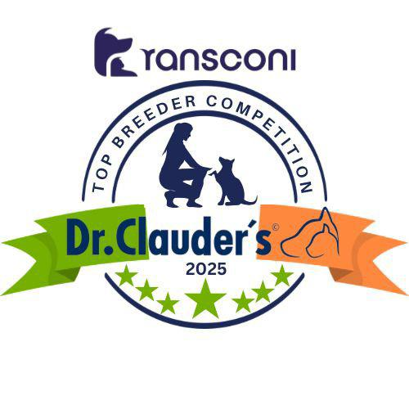
GROUP 2

AFFENPINSCHER
Messrs Isherwood & Gadsby (Afterglow) 8

BERNESE MOUNTAIN DOG
Mr & Mrs May & Mrs Jackson (Sennen) 42

BLACK RUSSIAN TERRIER
Paul Perks (Dromnagus) 73

BOXER
Amanda Payne (Willow) 24

BULLDOG
Aidan Brosnan (Starbornbullies) 47

BULLMASTIFF
Chris Roberts (Joybull) 34

CAUSASIAN SHEPHERD DOG
D.Strazda (Dominus Manerli) 6

DOBERMANN PINSCHER
Triona Ni She (Ruholfia) 61

DOGO ARGENTINO
Marek Males (La Fiera Blanca) 12

DOGUE DE BORDEAUX
Stuart Jess (Dromerez) 20

ESTRALA MOUNTAIN DOG (Long Haired)
Acinom Agricultura Lda (Da Acinoomagricultura) 16

GERMAN PINSCHER
Giovanni Vergari 13

GIANT SCHNAUZER
Ann McDonald (Velournoir) 35

GREAT DANE
Zoe Small (Islandrose) 31

HOVAWART
Matt & Britta Bos (Brandanerhof) 31

ITALIAN CORSO DOG
Jackie Prior (Jacdmar) 54

LEONBERGER
Diane & Lauren Whan (Sulandi) 29

MASTIFF
Mr & Mrs Coulman-Hole (Womlu) 39

NEAPOLITAN MASTIFF
Emiliano Messina 26

NEWFOUNDLAND
Mr & Mrs McVea (Snugines) 96

PINSCHER MINIATURE
Angela McNally (Assisi) 47

PYRENEAN MASTIFF
Shane Tychowski (Mendiko) 5

PYRENEAN MOUNTAIN DOG
Ms M Morawiak (Mysticelysium) 27

ROTTWEILER
Erika Steohanauskiene (Rojaus Slenio) 32

SCHNAUZER MINIATURE
Sylwia Kostecka (Sancycharm) 24

SCHNAUZER STANDARD
Phil Boulton (Boujan) 24

SHAR PEI
Silvia Vannucci (Huang Di) 15

ST BERNARD L/H
Mr & Mrs Sheehan (Parleshan) 68

ST BERNARD S/H
Mr & Mrs Sheehan (Parleshan) 42

TIBETAN MASTIFF
Mr Cervenak & Miss Ruzickova (Wangdak) 10

Group 2 Leaders
Snugines Newfoundlands (96)
Congratulations to the Leaders
in the DR CLAUDERS
Top Breeder Competition 2025
The competition identifies the most consistent Breeders of top winning dogs at All Breed Championship Shows within each breed and ran from
1st January to 31st December, 2025
(Results up to and Including All Irl Bull Breeds)

Breeders gain points from Green Star wins at
ALL BREED CHAMPIONSHIP SHOWS as follows:
5 POINTS awarded for the first Green Star won by a dog of their breeding
1 POINT awarded for subsequent Green Stars won by that same dog.

Each Breed Winner will receive a Diploma, Rosette and Product
Each Group Winner will receive a Diploma, Rosette, Crystal and Product
There will also be a prize for the Overall WinnerKI.

